Inventory Management System

Manual

Contents

Revision Sheet 3

Login 4

Forgot your Password or need to reset? 5

Add non existing Item to the Inventory 6

Add Receivables 7

Log Request 8

Update an Item in Inventory 9

Delete an Item 10

Edit Item 11

Create User 12

Change User Password 13

Generate Report 14

# Revision Sheet

|  |  |  |  |
| --- | --- | --- | --- |
| **Version No.** | **Date** | **Revision Description** | **Author** |
| v. 0 | 17/03/16 | Major Functionalities Outlined | Yanik Blake |
|  |  |  |  |
|  |  |  |  |
|  |  |  |  |
|  |  |  |  |
|  |  |  |  |
|  |  |  |  |

# Login

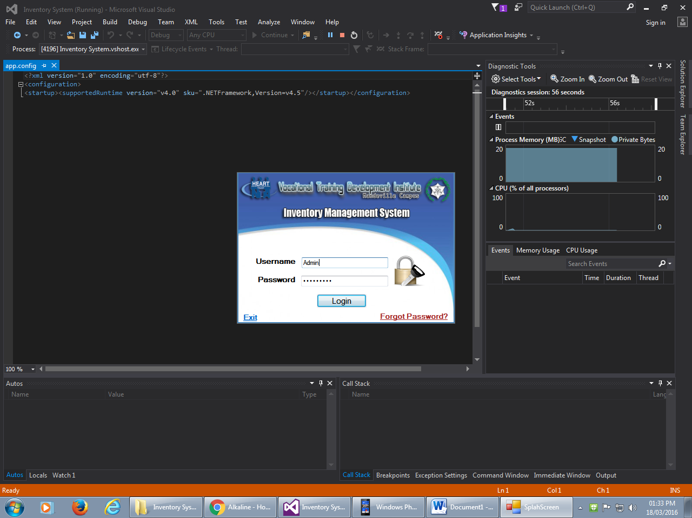

Steps

1. Enter username and password
2. Select Login or Enter

# Forgot your Password or need to reset?

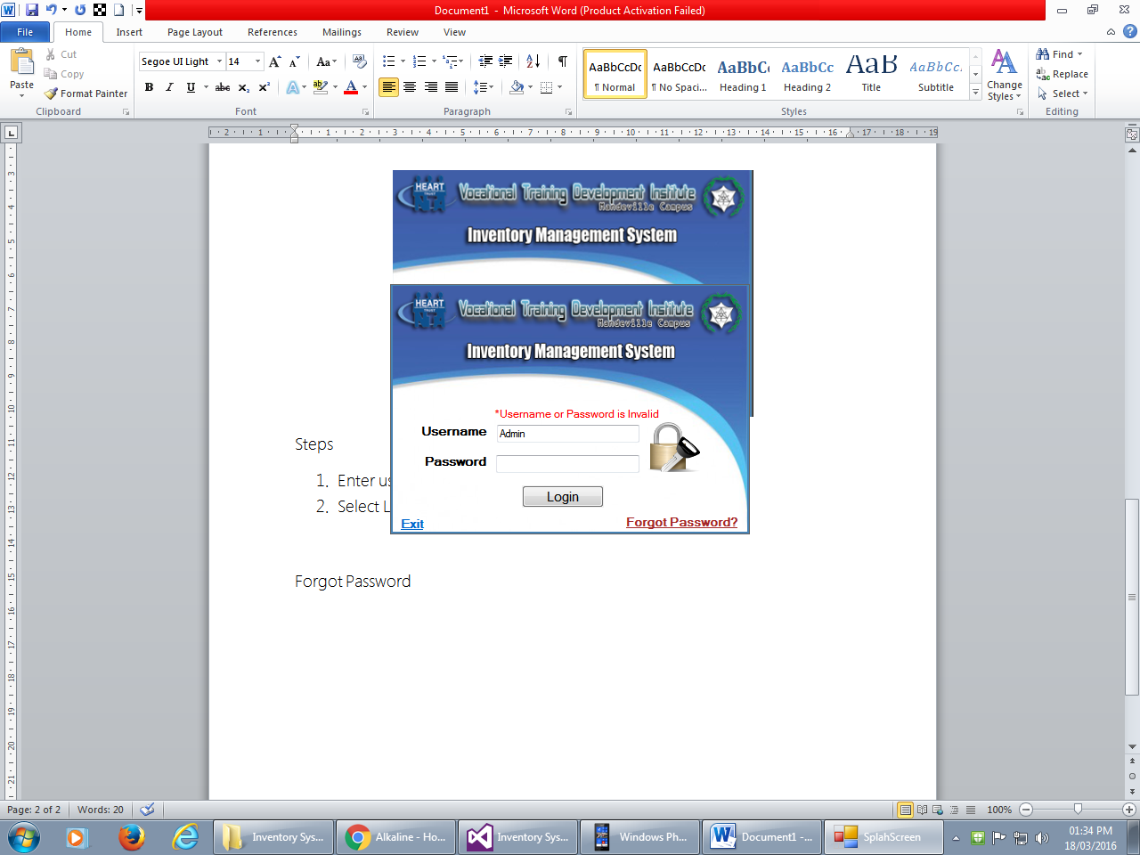

Steps

1. Click “Forgot Password?” link at the bottom right of the login screen.
2. The form below will appear. Enter the information required and click “Reset” button

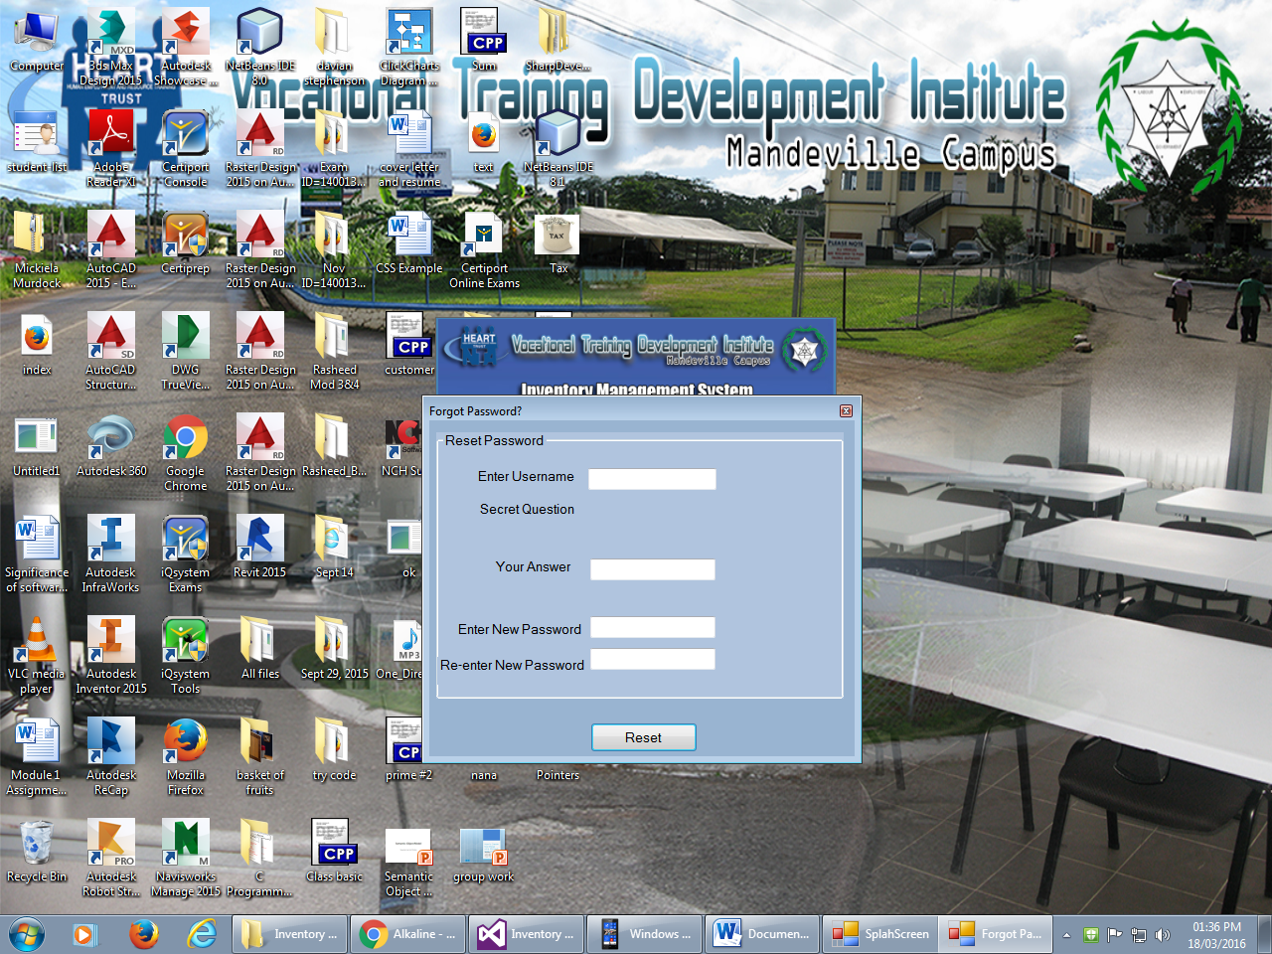

1. If the information is correct proceed to the login screen

# Add non existing Item to the Inventory

Steps

1. Click Add New Item Icon 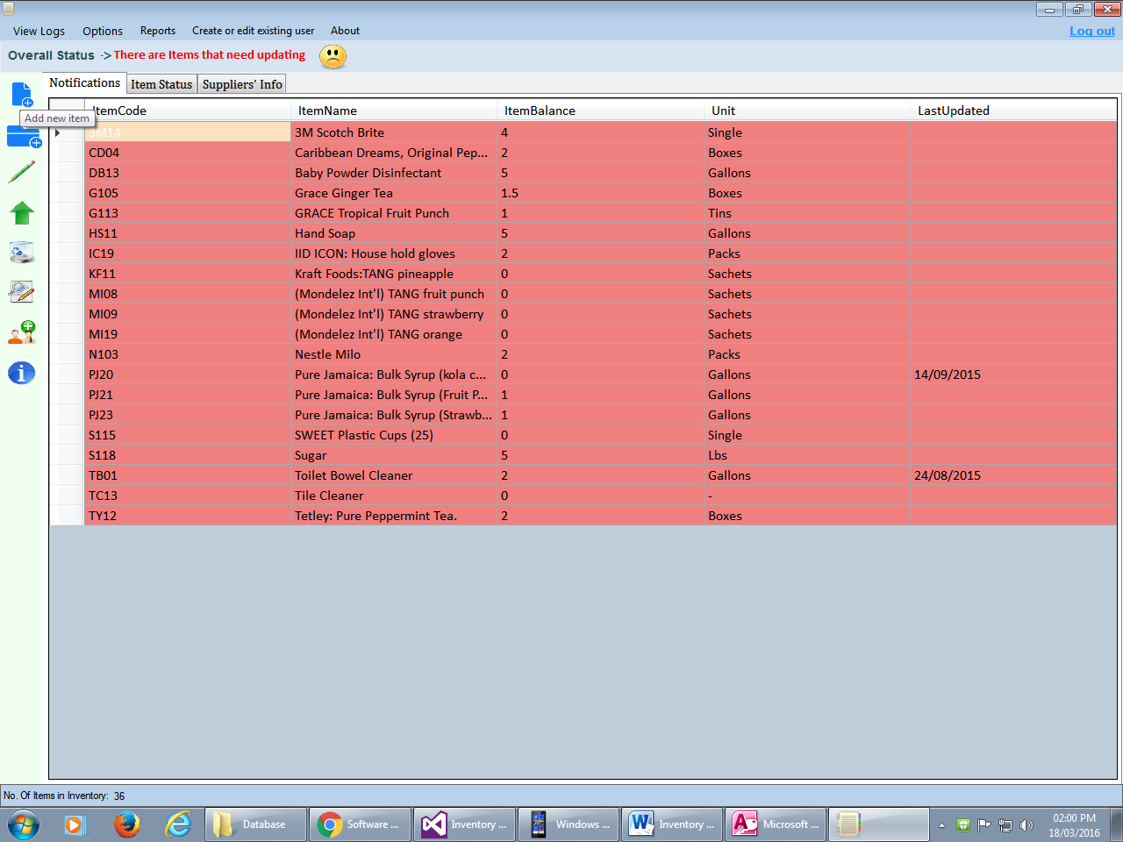 or choose “add new Item” from options 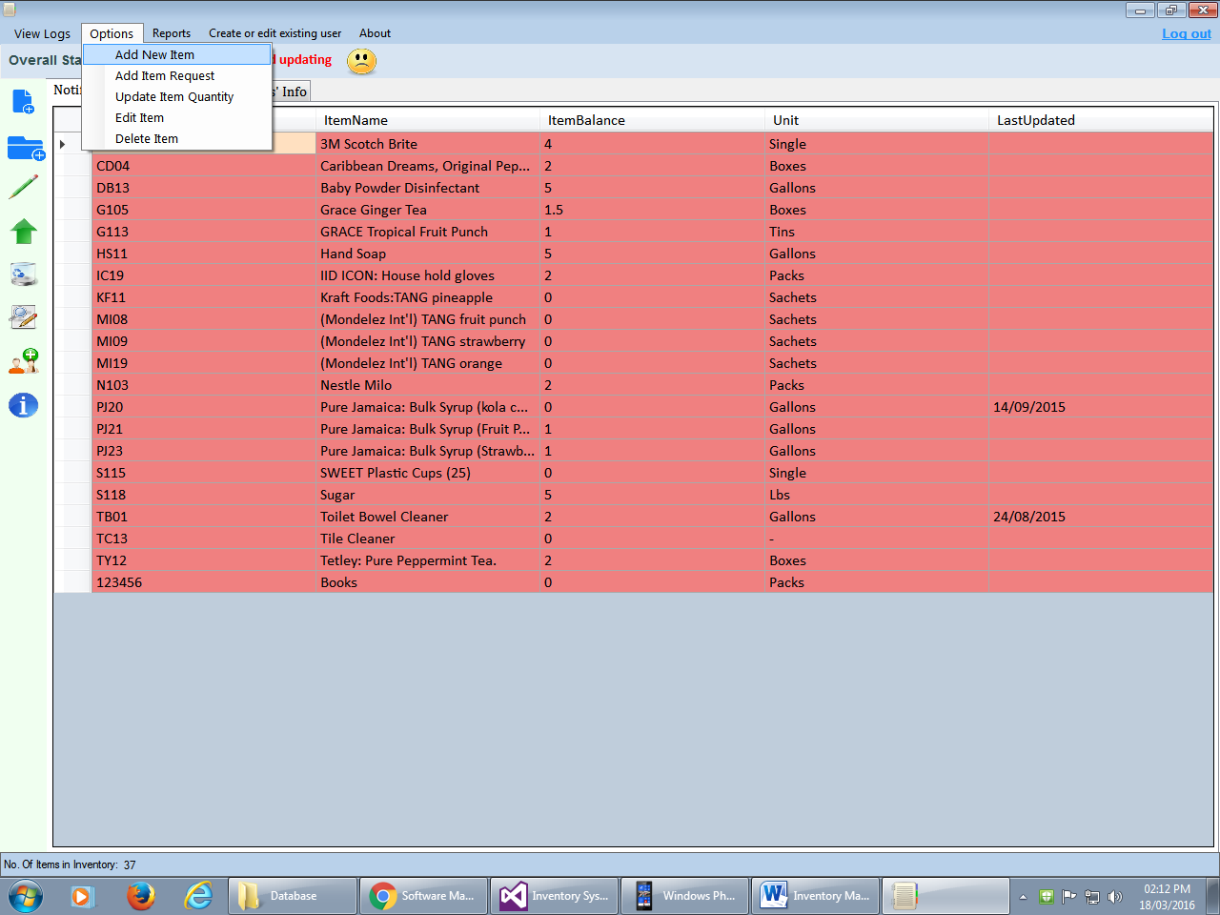
2. An “Add new Item” Form will appear. Enter the required Information then click Submit button.

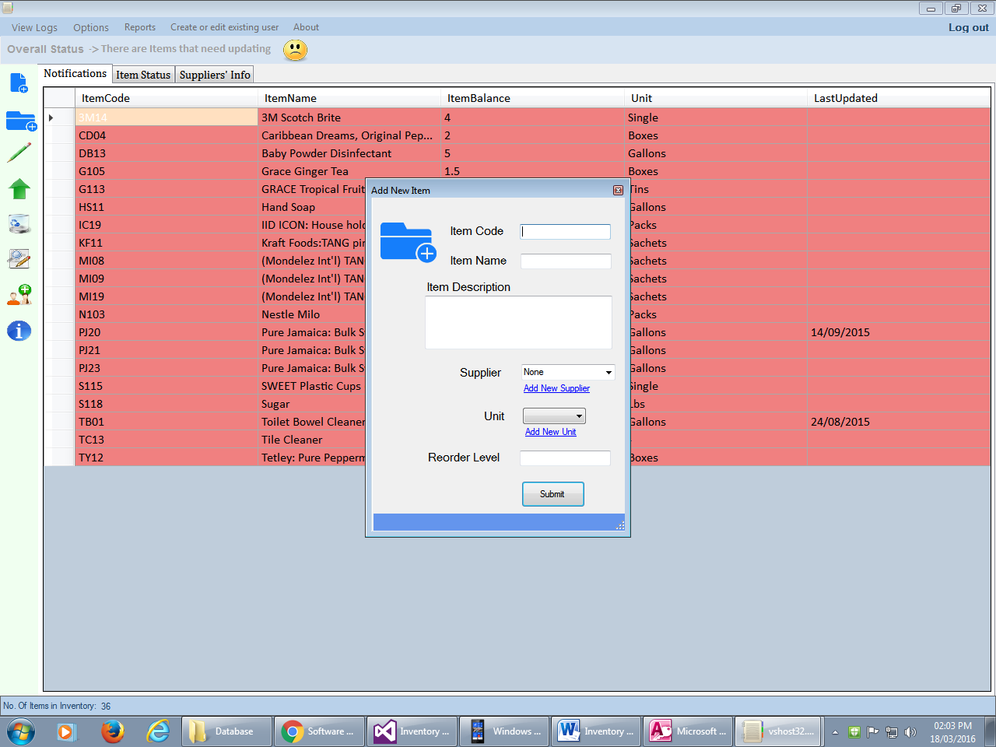 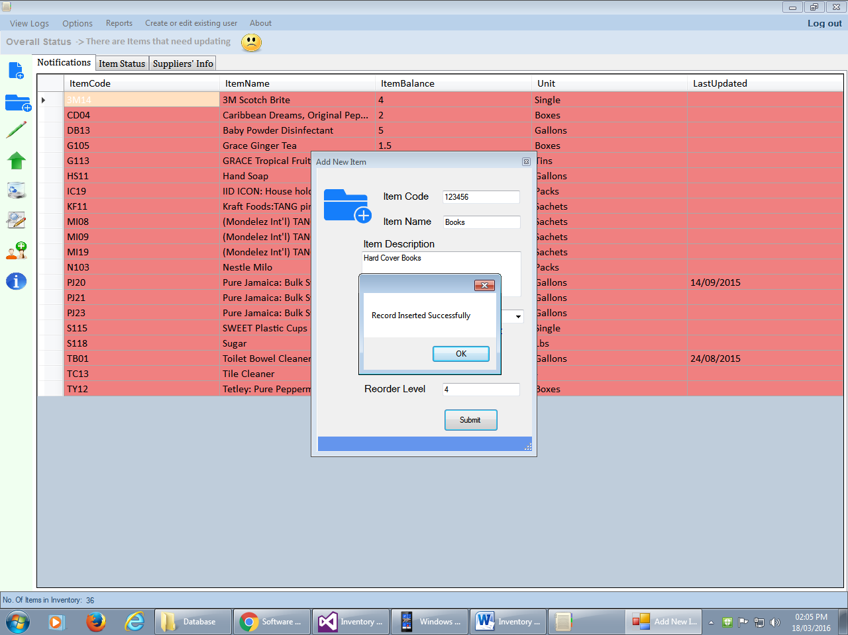

1. A success message will appear if information was entered correctly
2. Another form will appear to enter the number of quantity and cost (if any) of the item to be added to the system. Fill out the information then click “save” button. If successful a successful message will be display.

# Add Receivables

1. Click Add Receivables icon 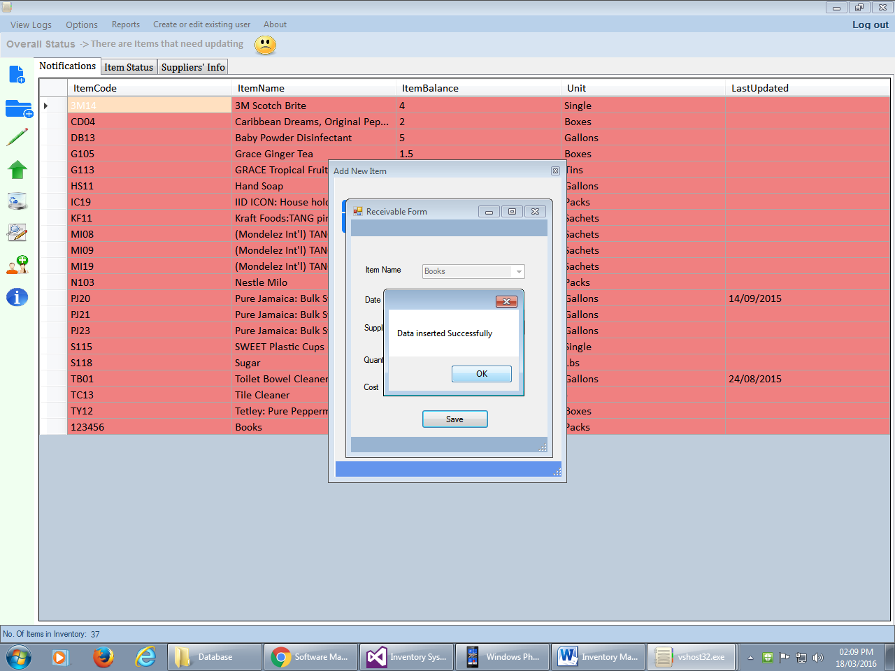 in or from the Options choose “Add Receivables” option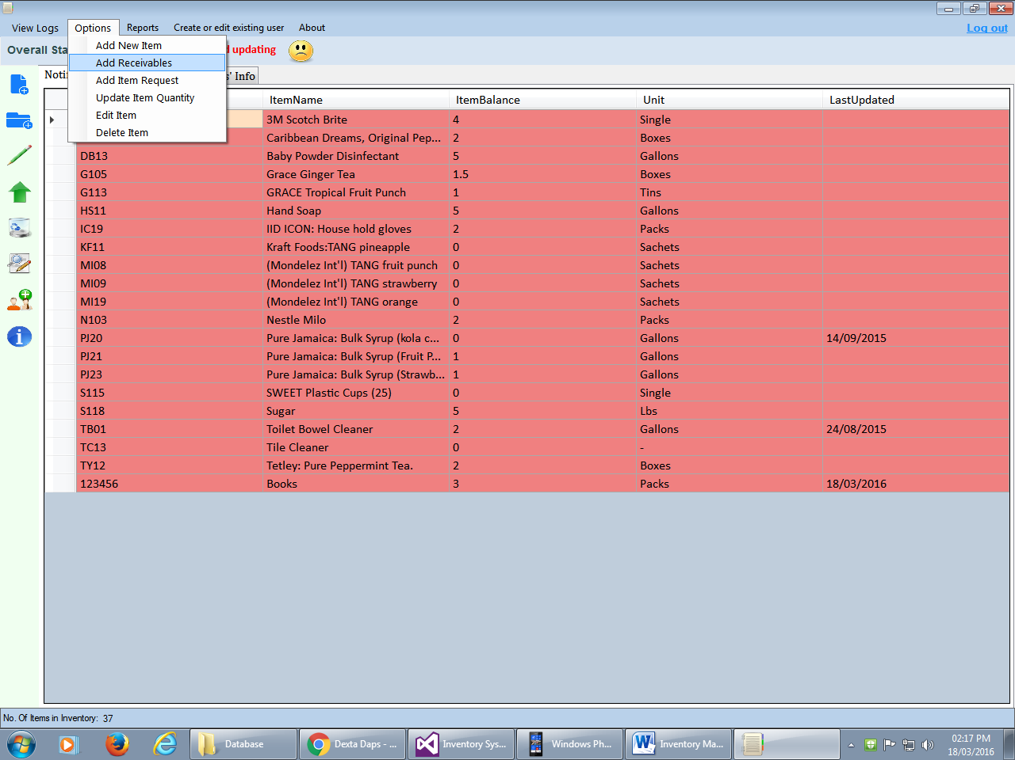
2. The form below will appear enter the information and then click “save” button. A successful message will be displayed if successful.

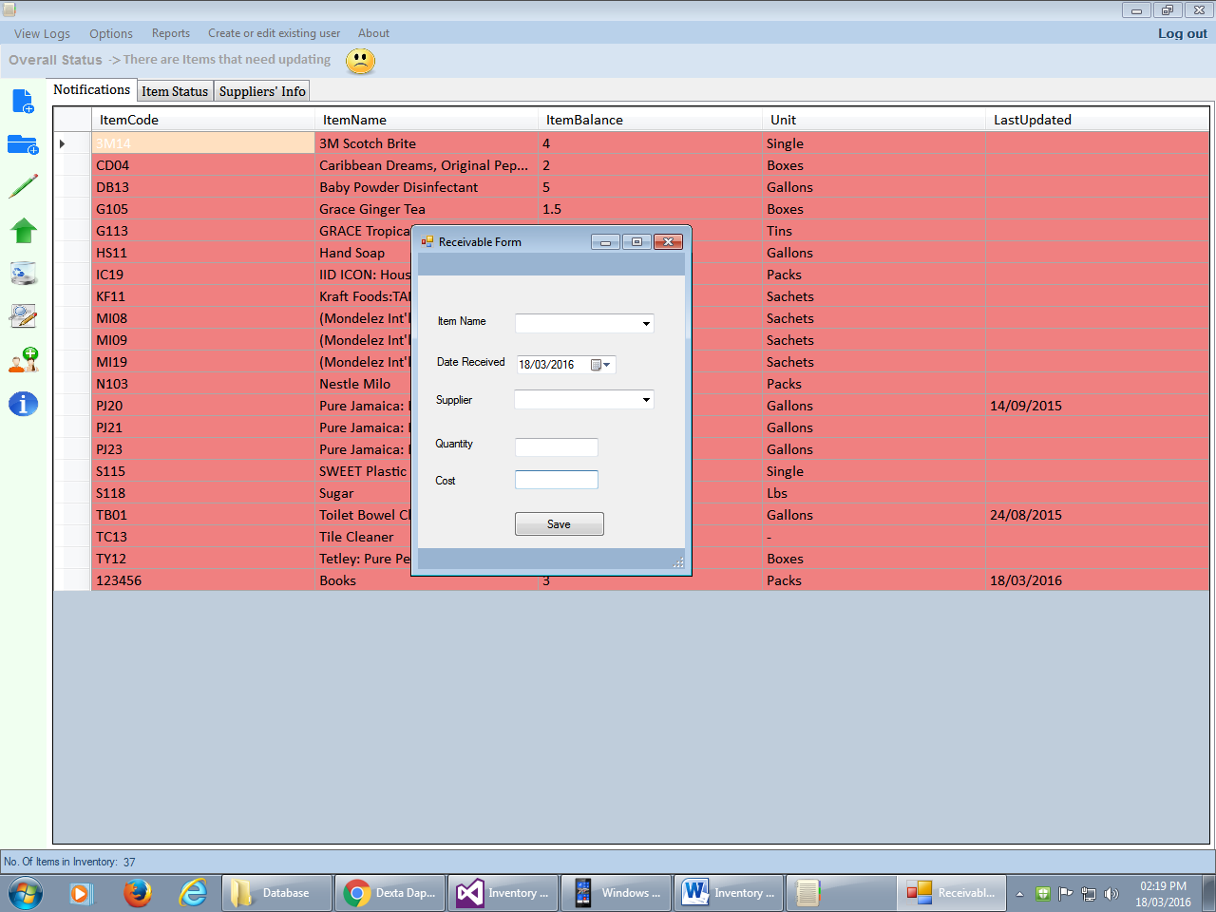 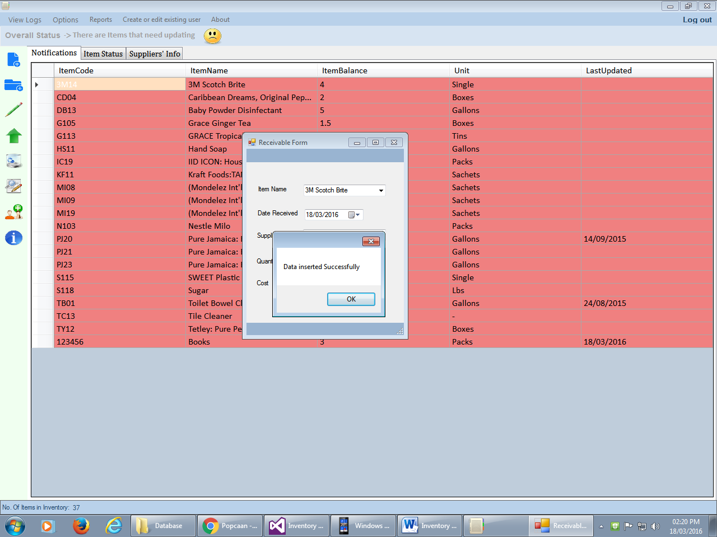

# Log Request

Steps

1. Click Log Request Icon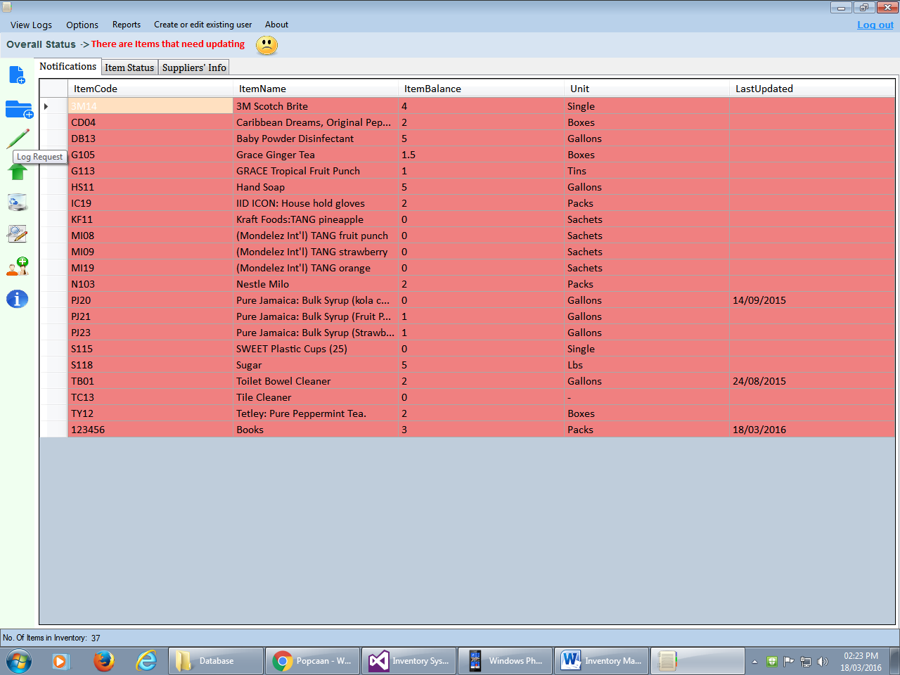 or Select “Log Request” from Options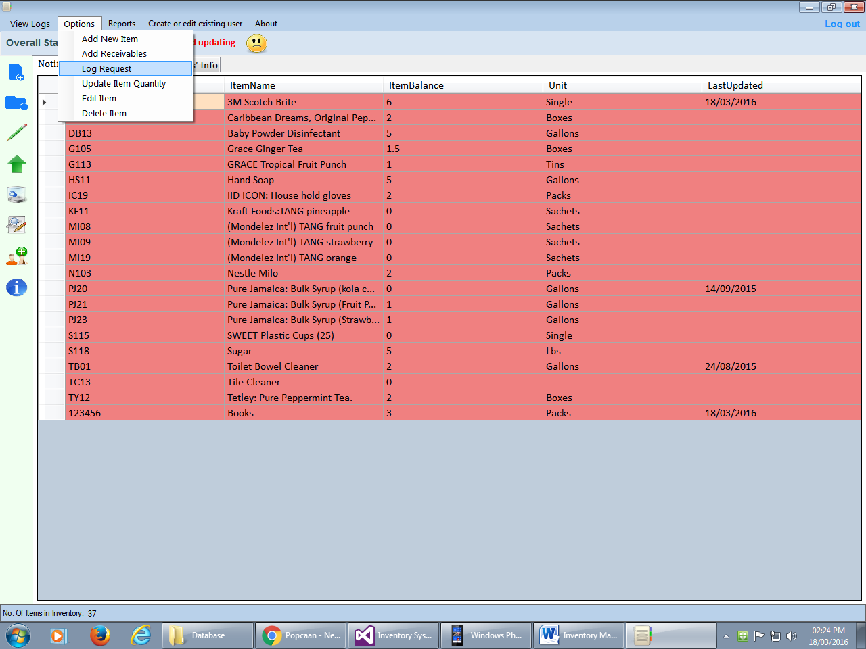
2. The form below will appear. Enter the information and click ”submit” Button. A successful message will appear

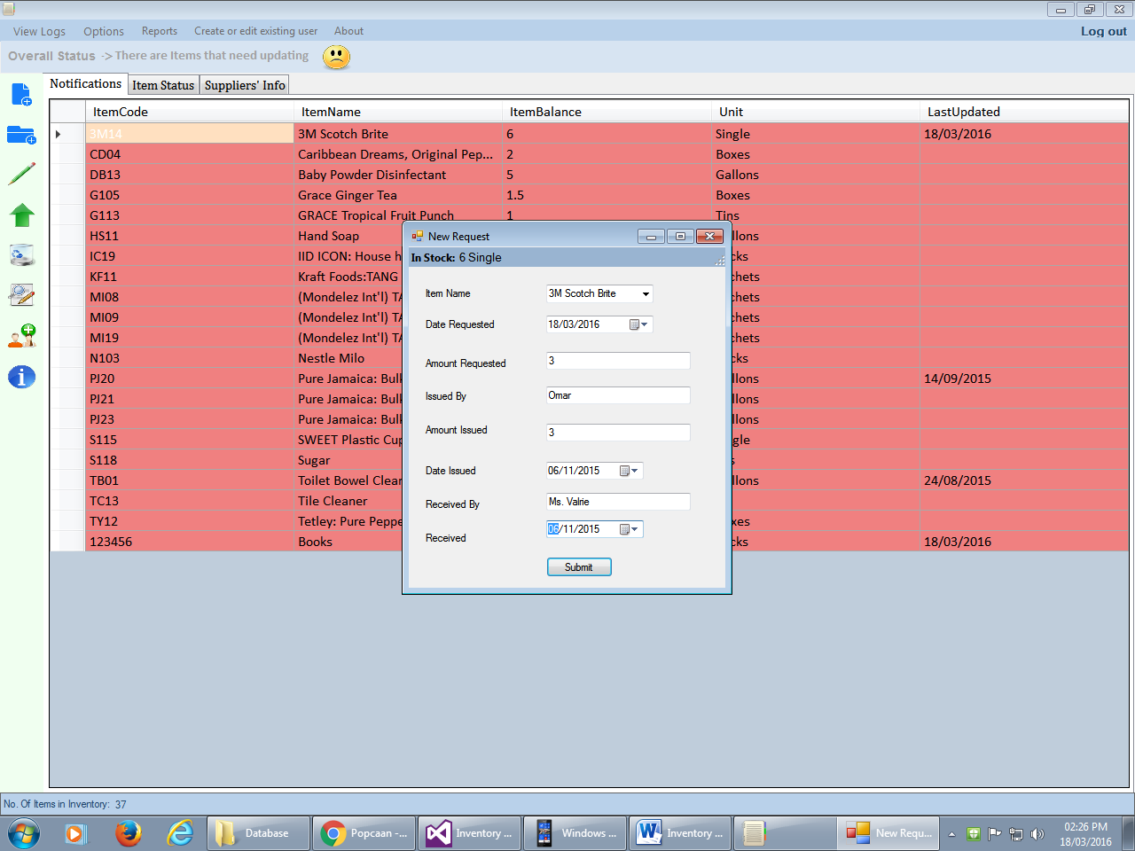 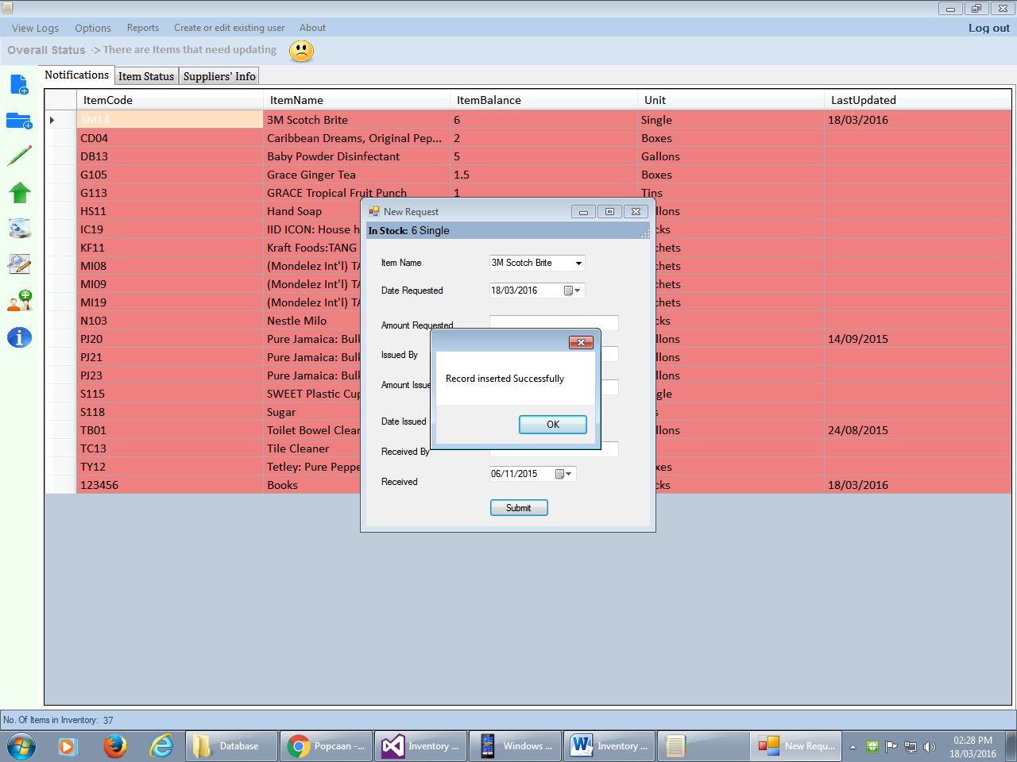

# Update an Item in Inventory

Steps

1. Click Icon 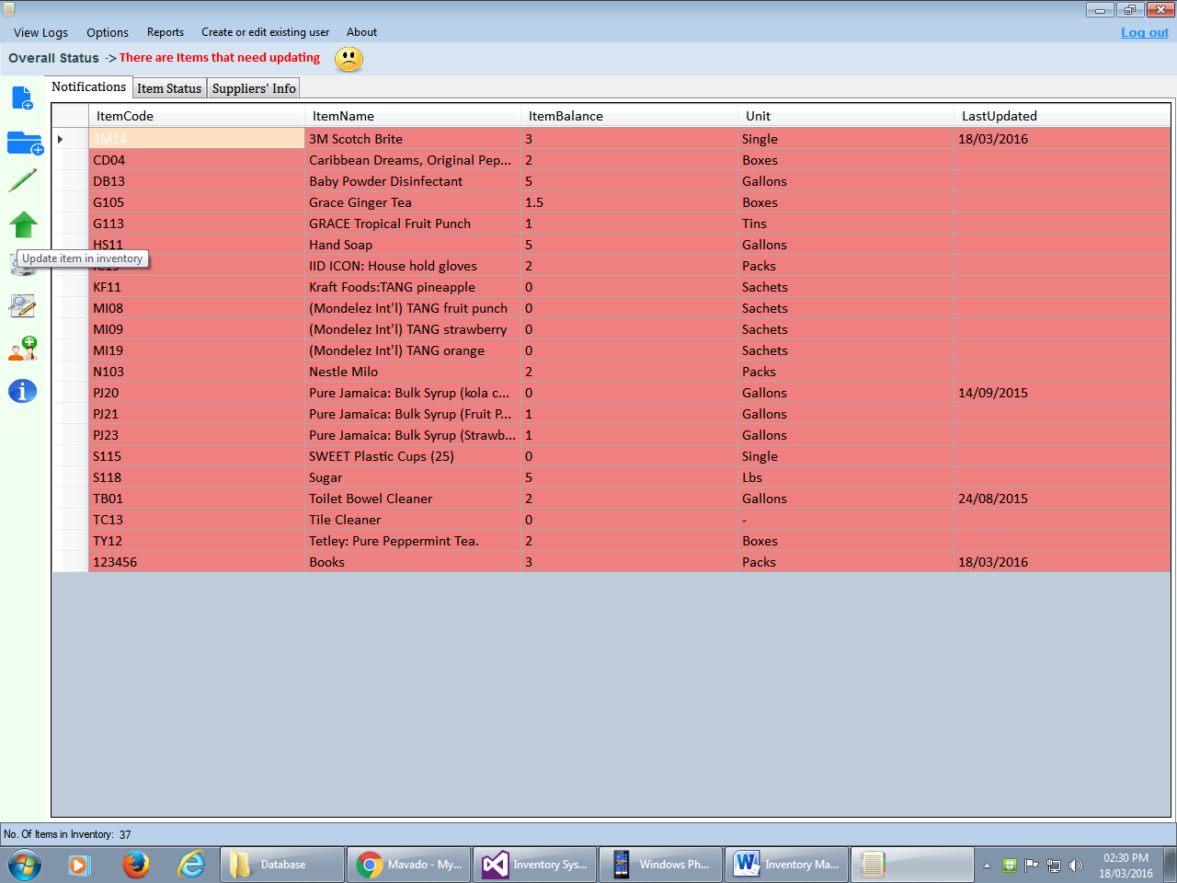 in figure or select “Update Item Quantity” from options 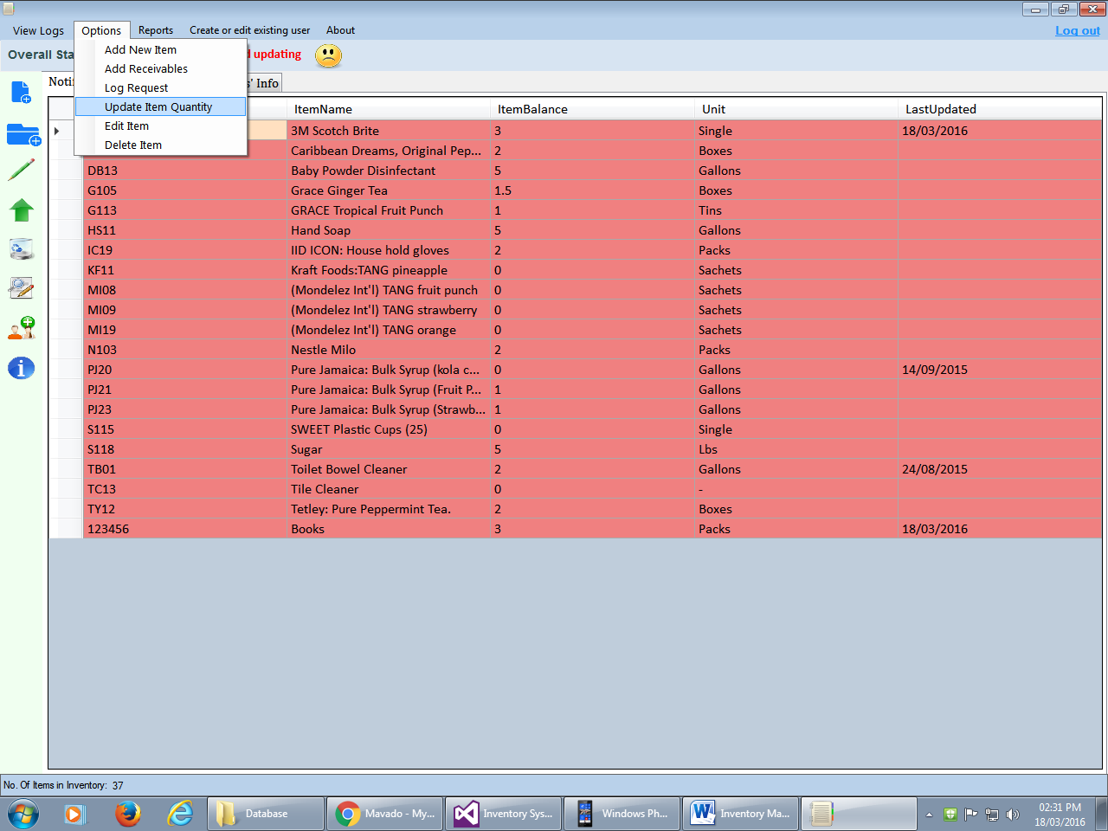
2. The form below will appear. Select the item you intend to update then enter the quantity and click “Update” button. If successful the “in stock” will reflect the changes.

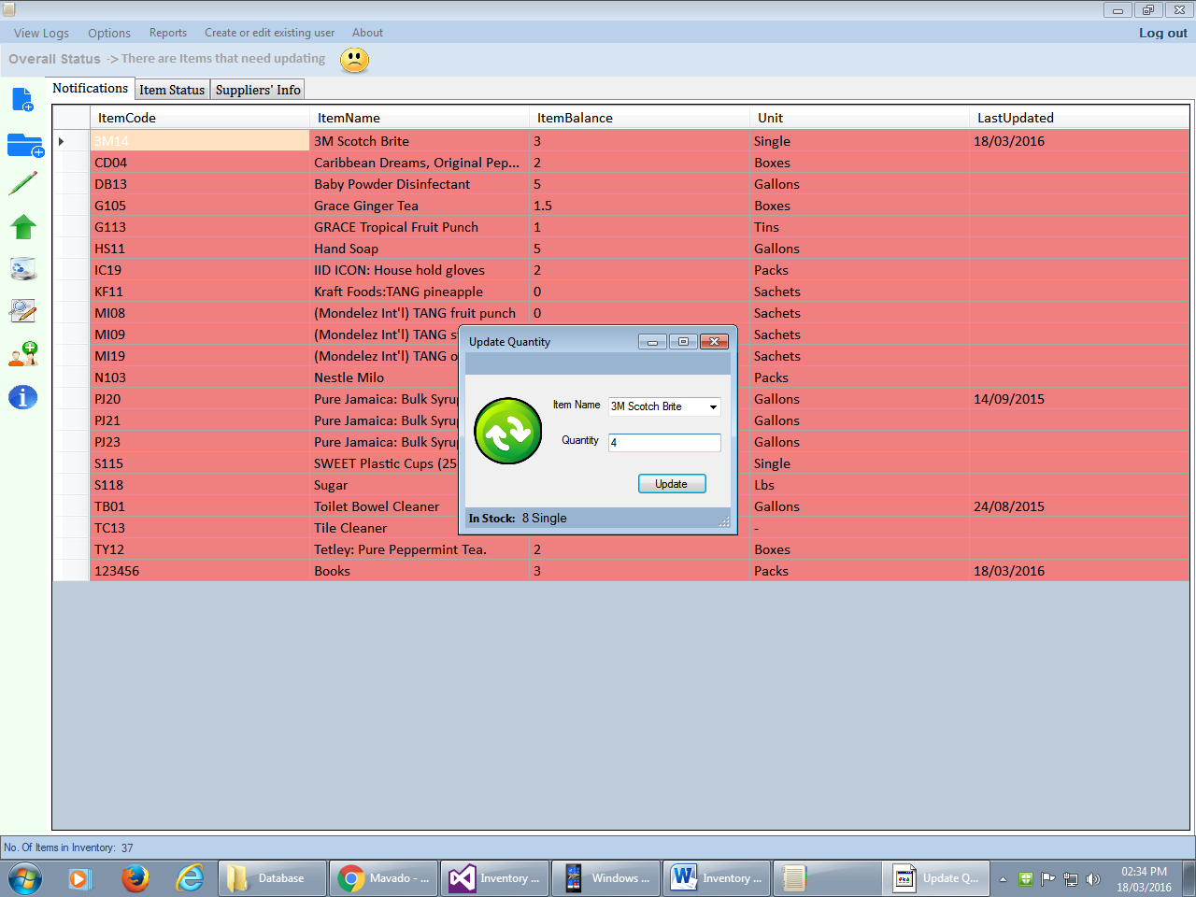 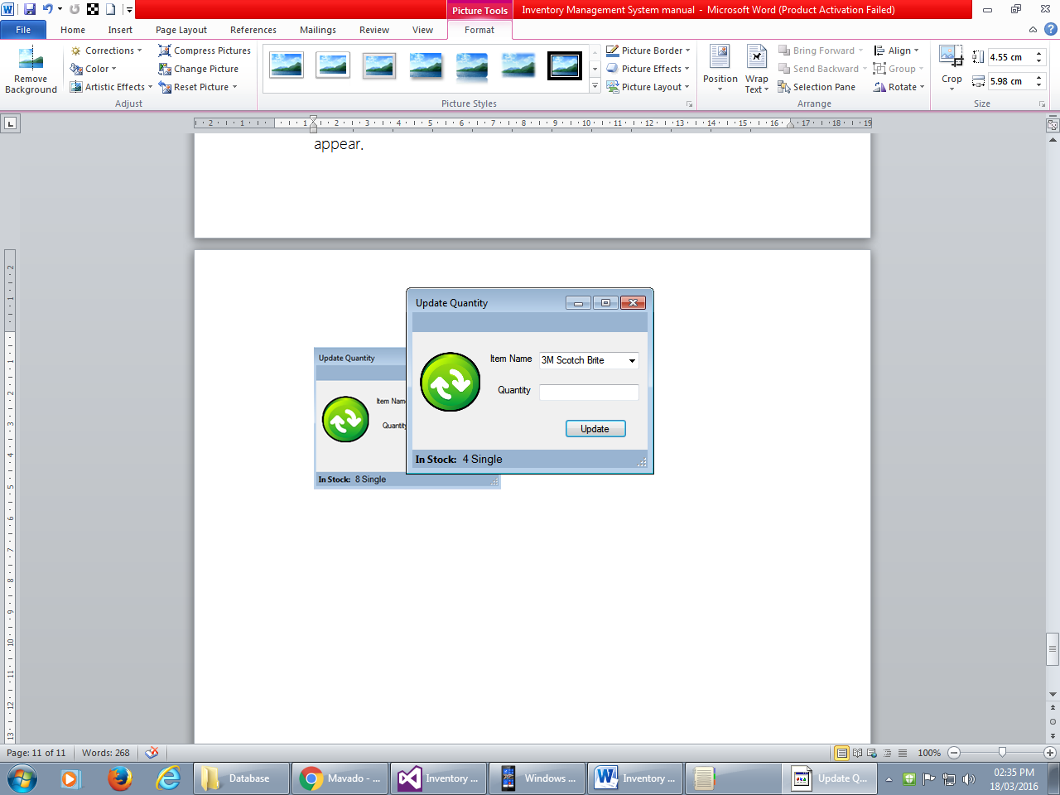

# Delete an Item

Steps

1. Click icon 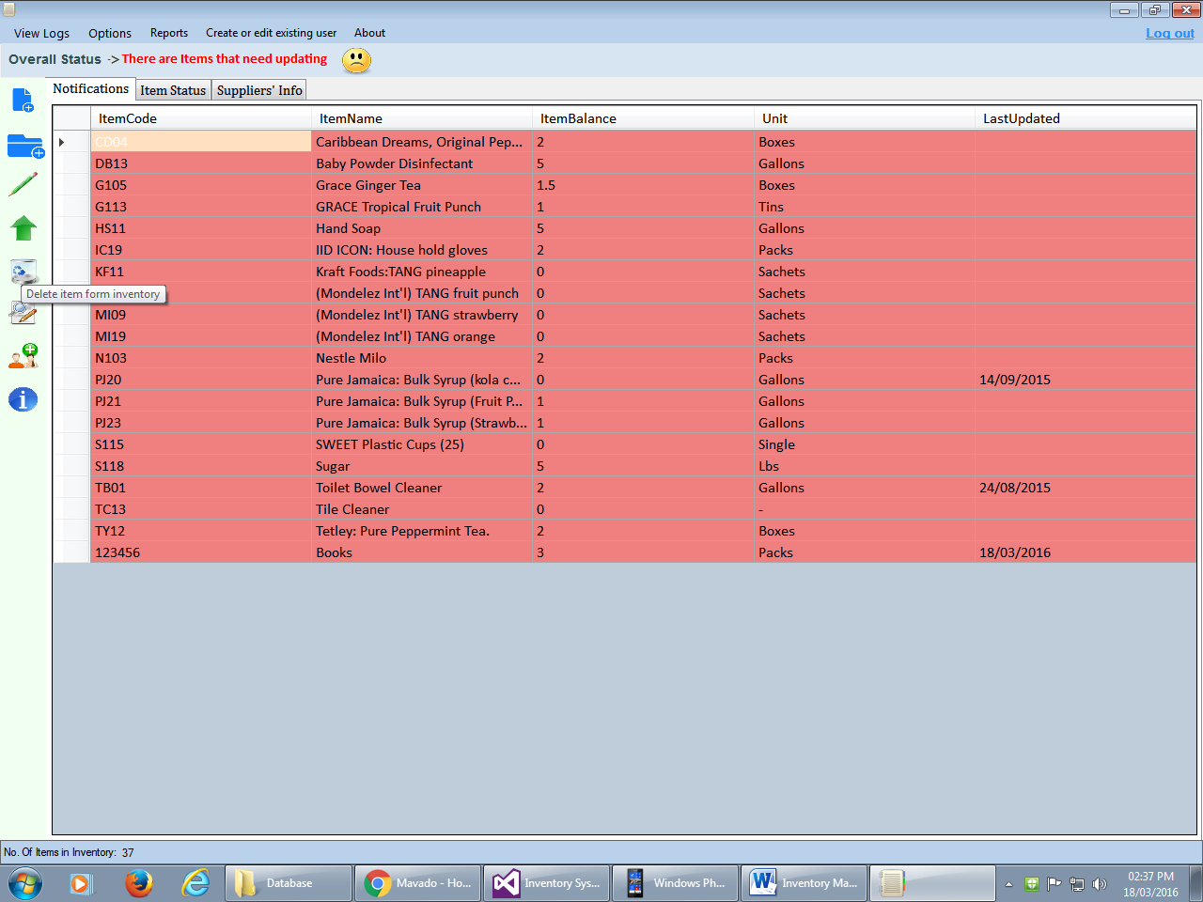 or select “Delete Item” from options 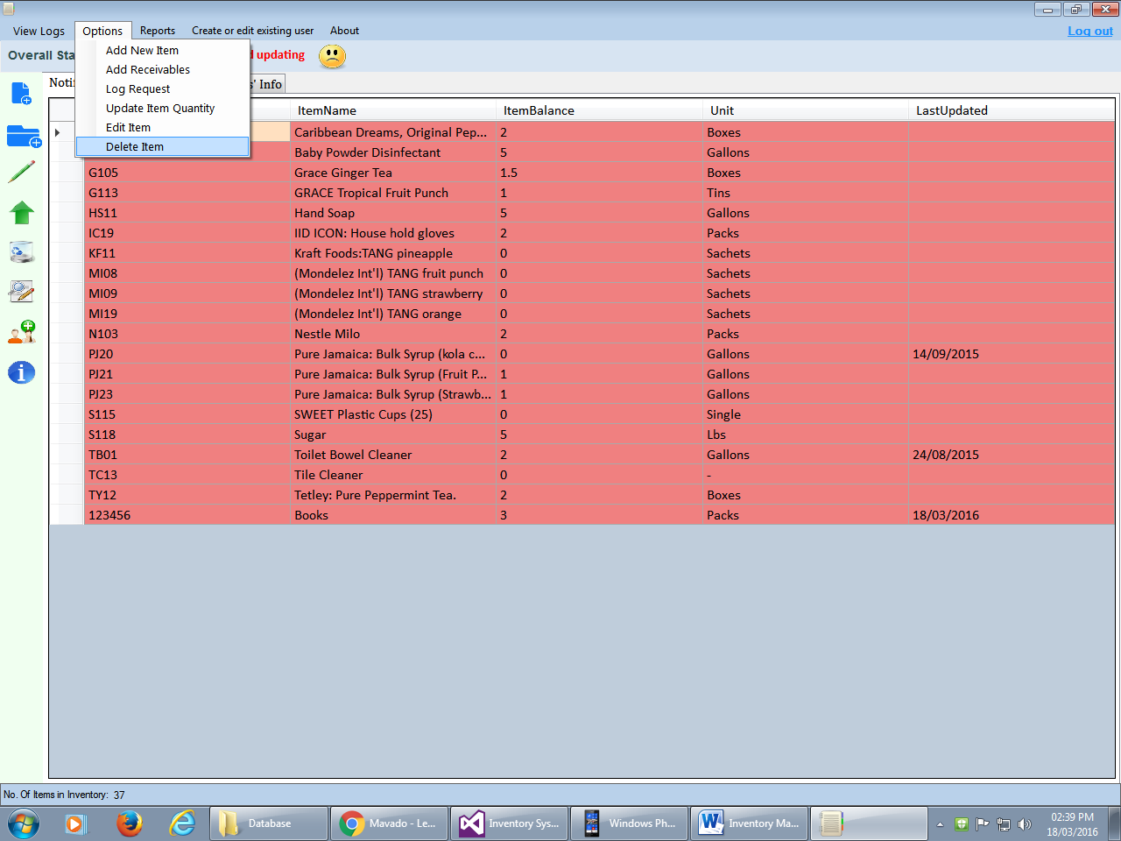
2. The form below will appear. Select the item and click delete button.

Click yes from dialog box. A message will be displayed confirming deletion.

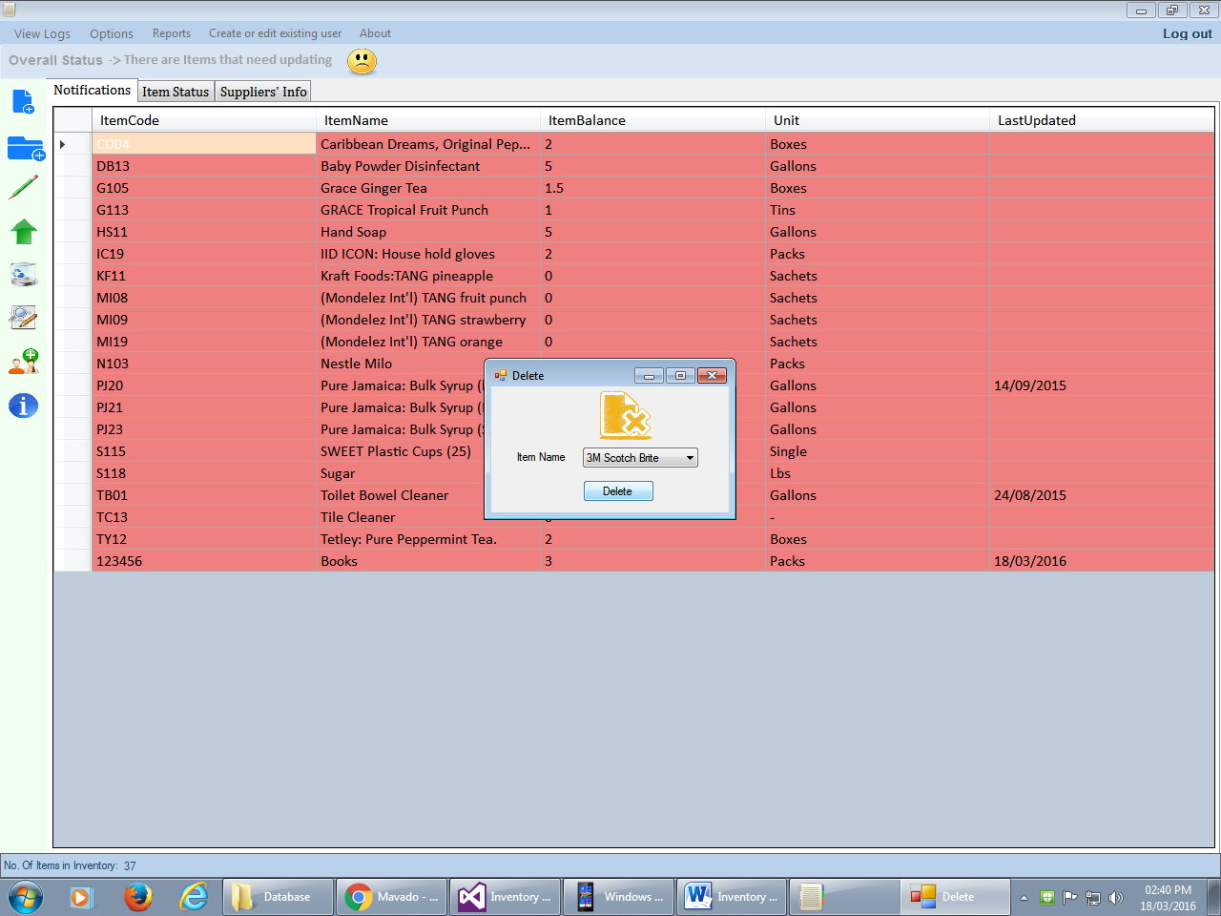 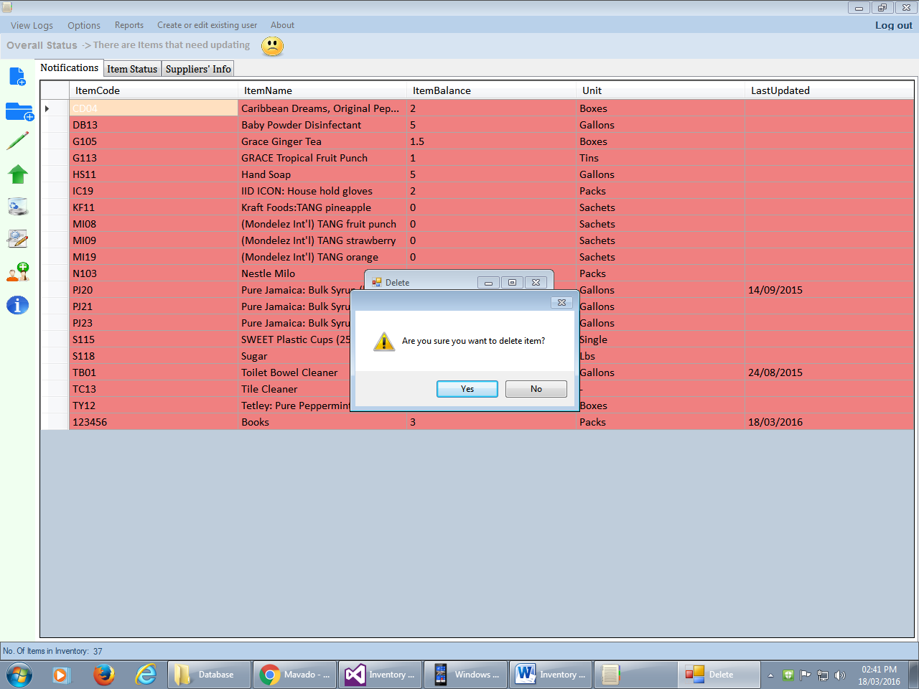 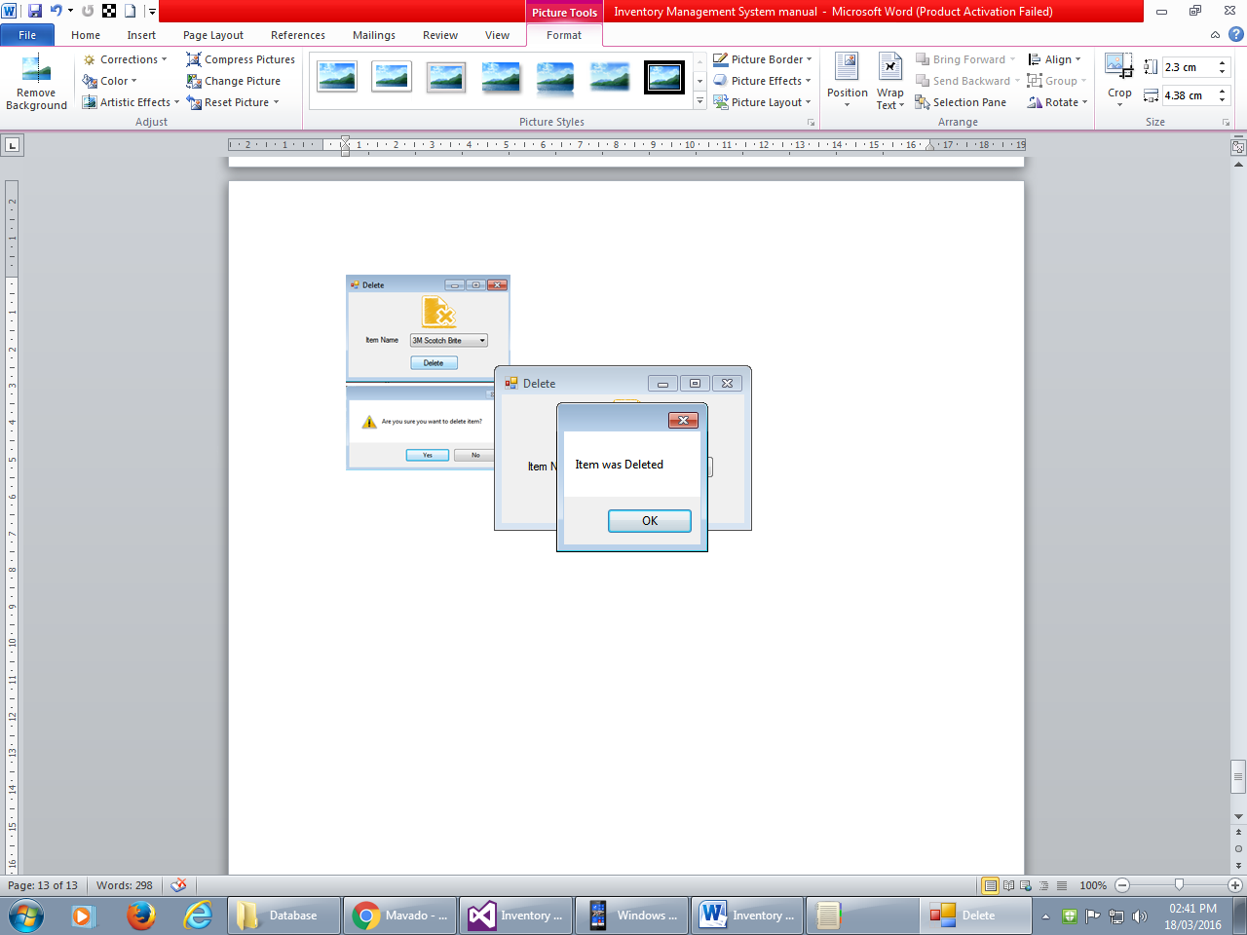

# Edit Item

Steps

1. Click icon 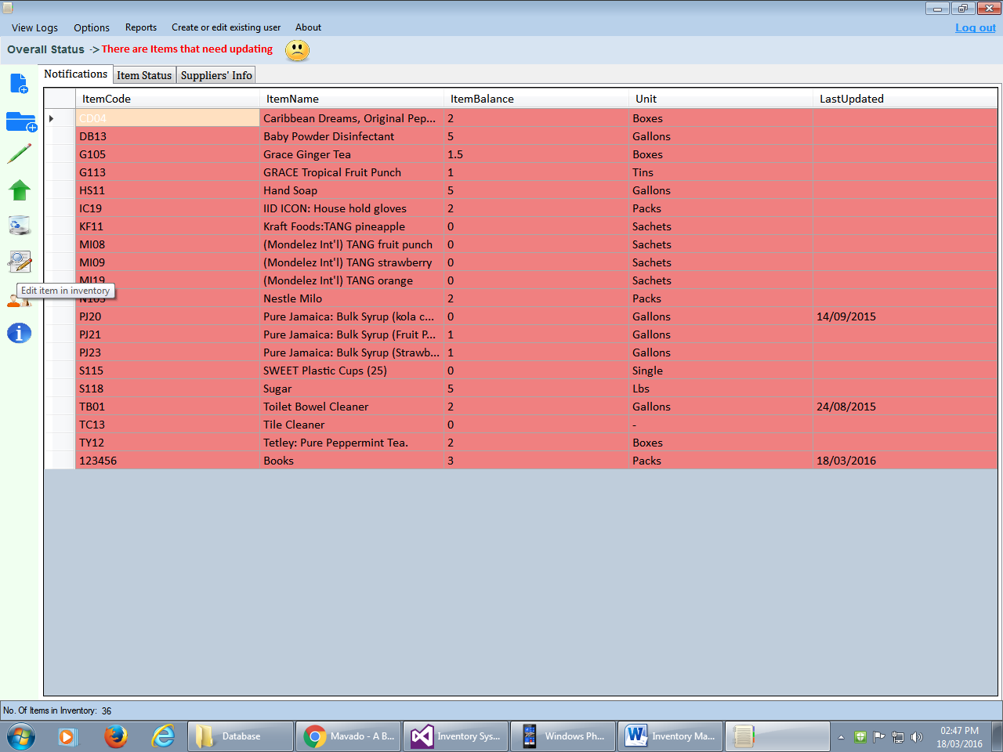 or select “Edit Item” from options.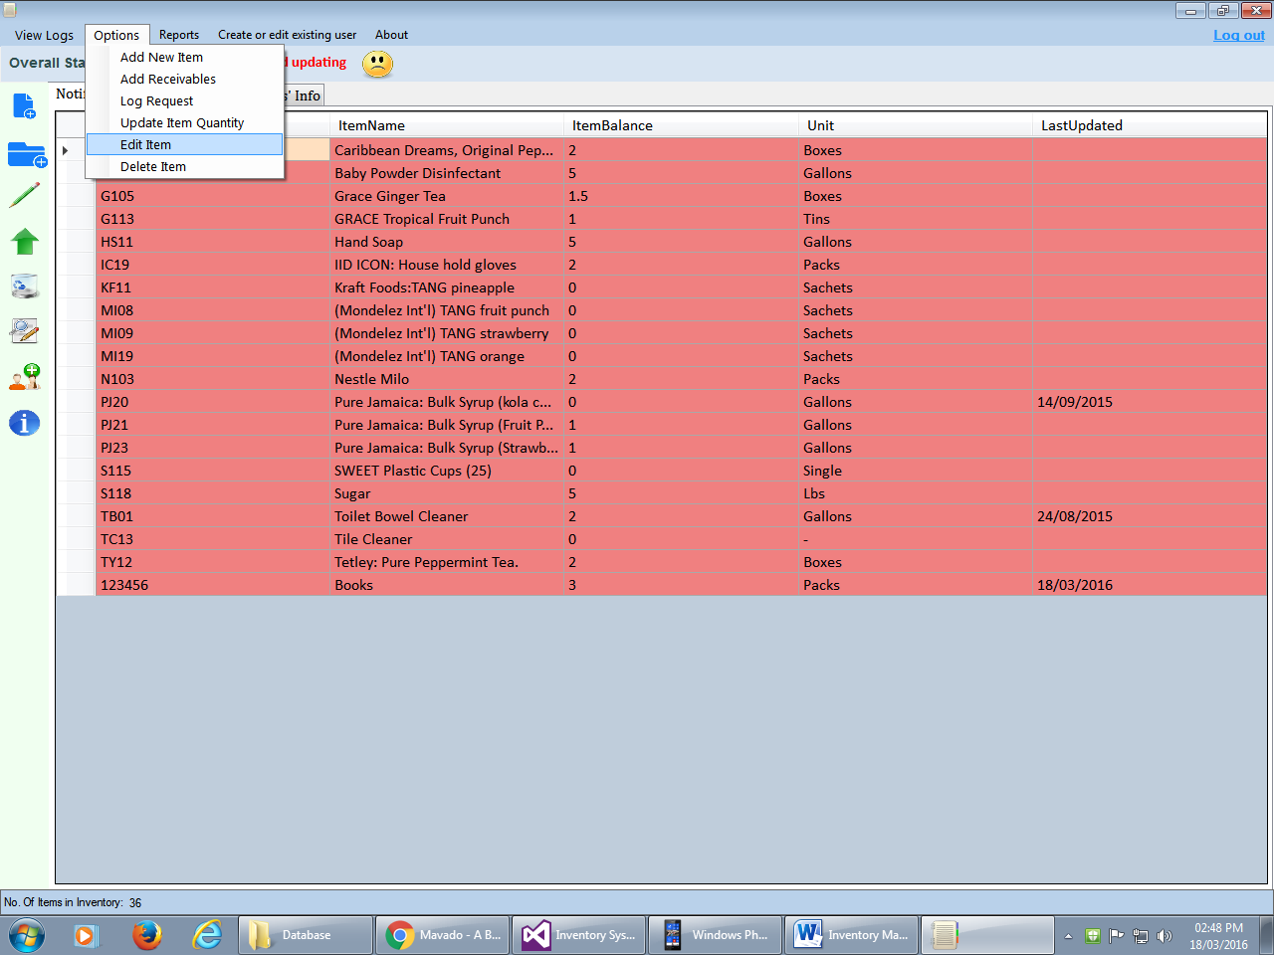.
2. The form below will appear. Select the item you want to edit from the item list. Edit the item information and click “save changes” button. Click “yes” form message dialog. Confirmation message will be displayed.

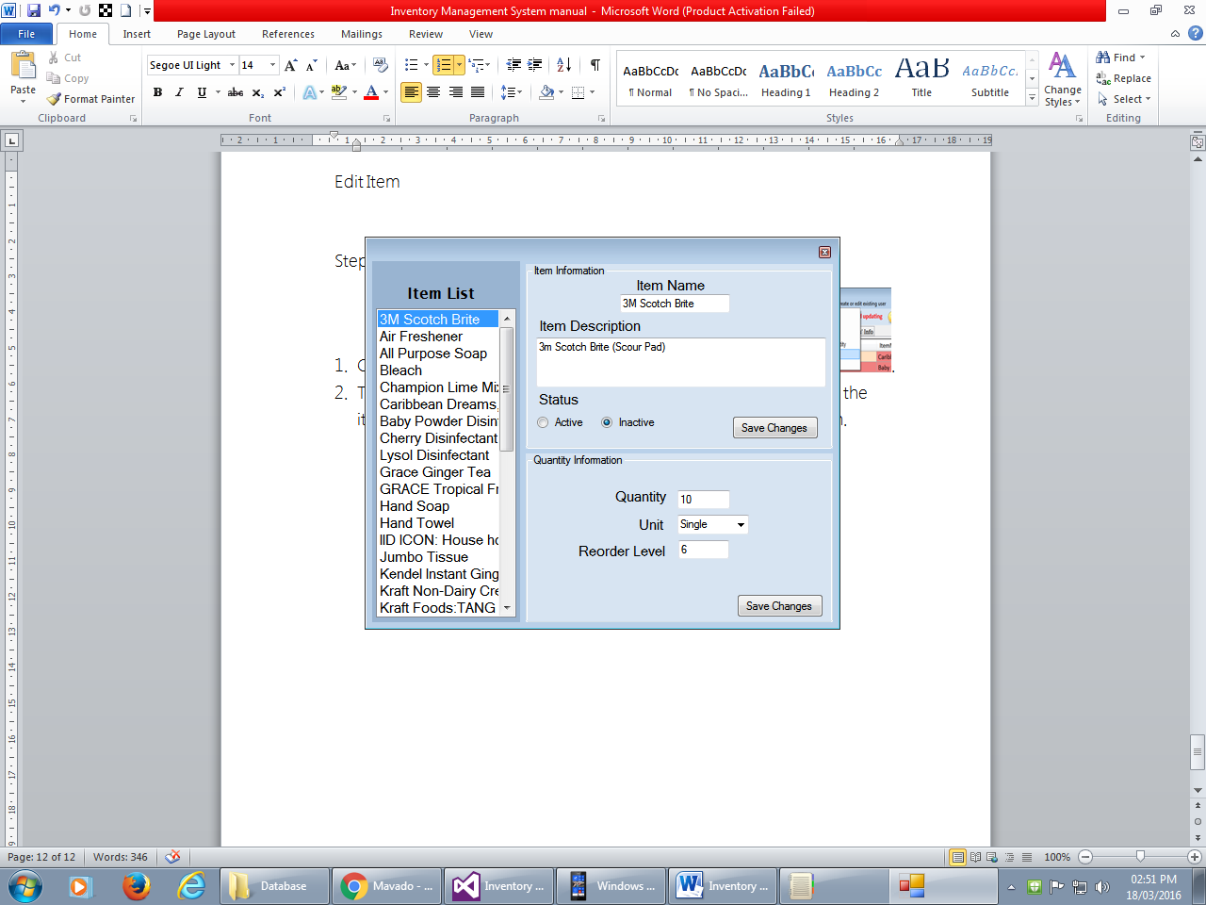 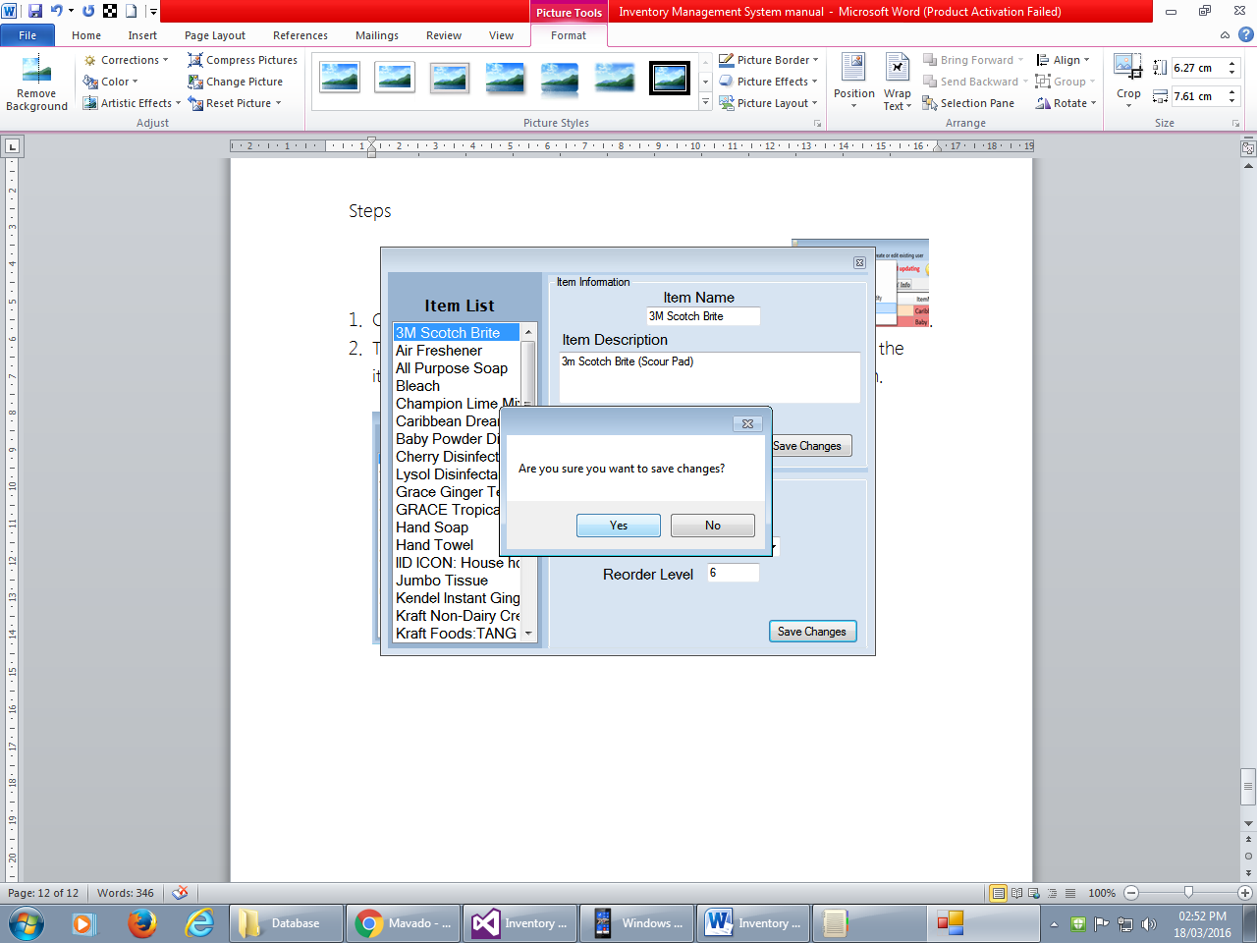

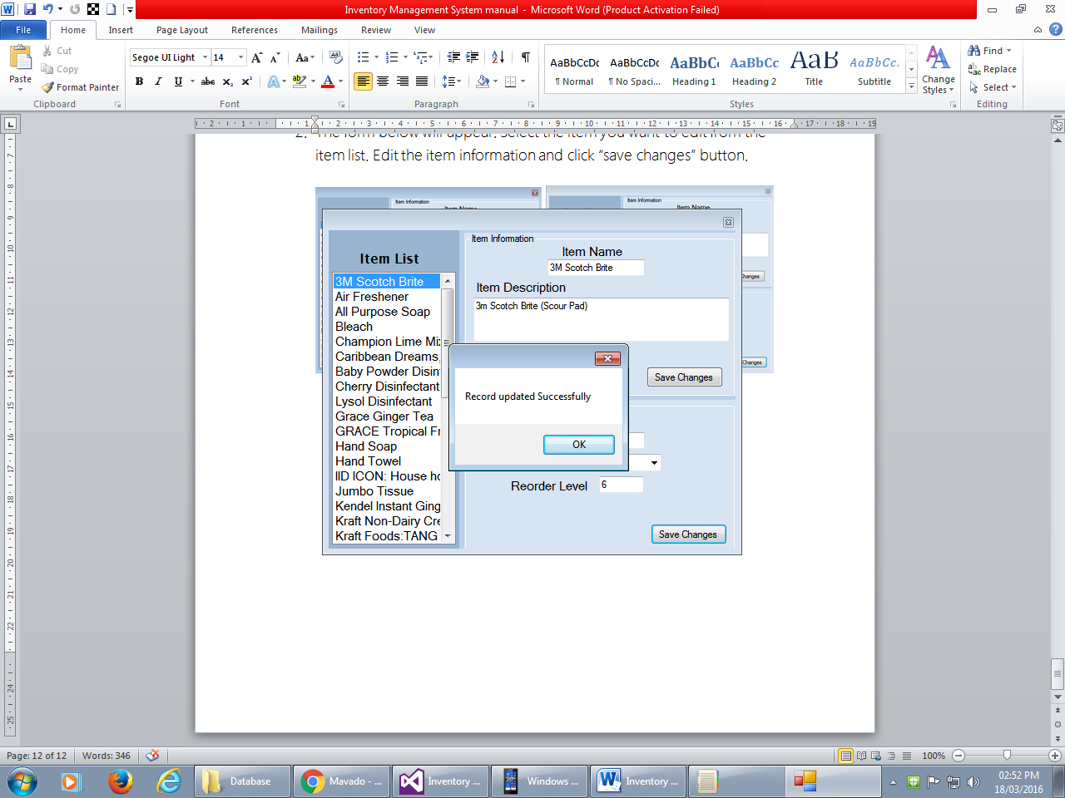

# Create User

Steps

1. Click Icon 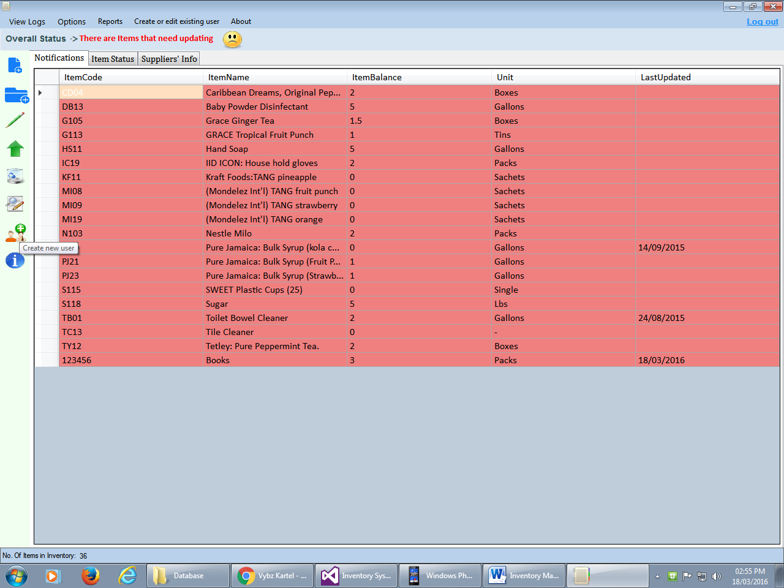 or Select “Create or edit existing user” option. 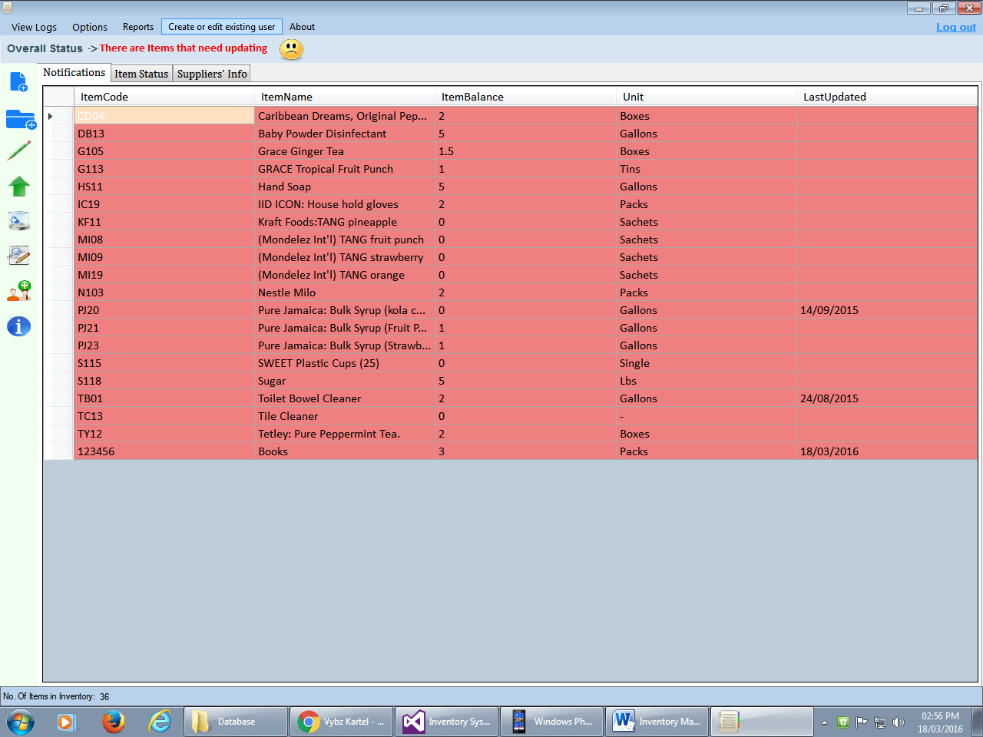
2. The form below will appear. Enter the information under the section “Create New User” and click “Create” button. A confirmation message will appear.

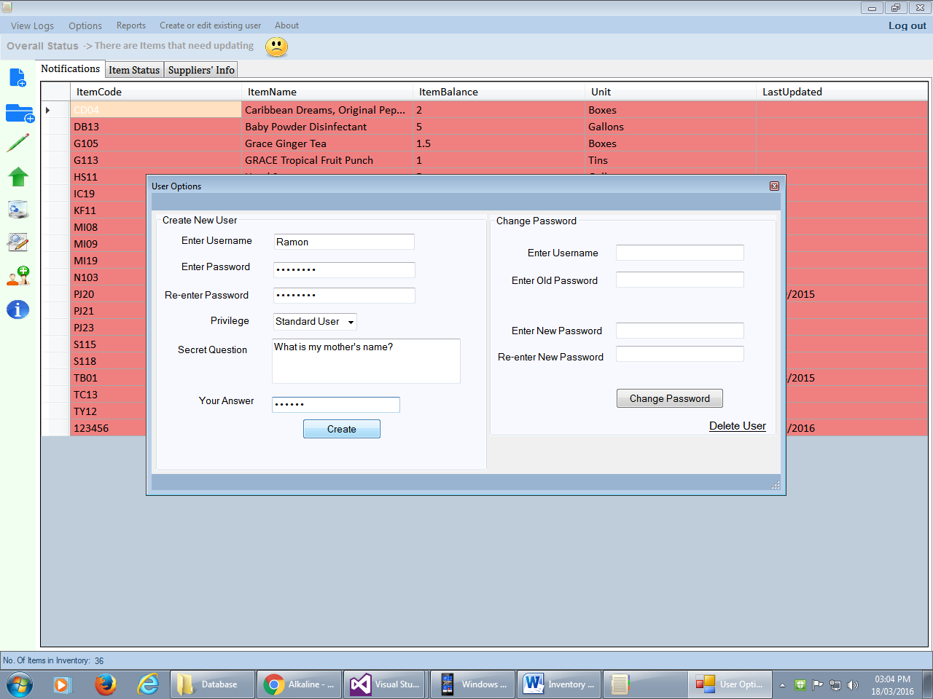

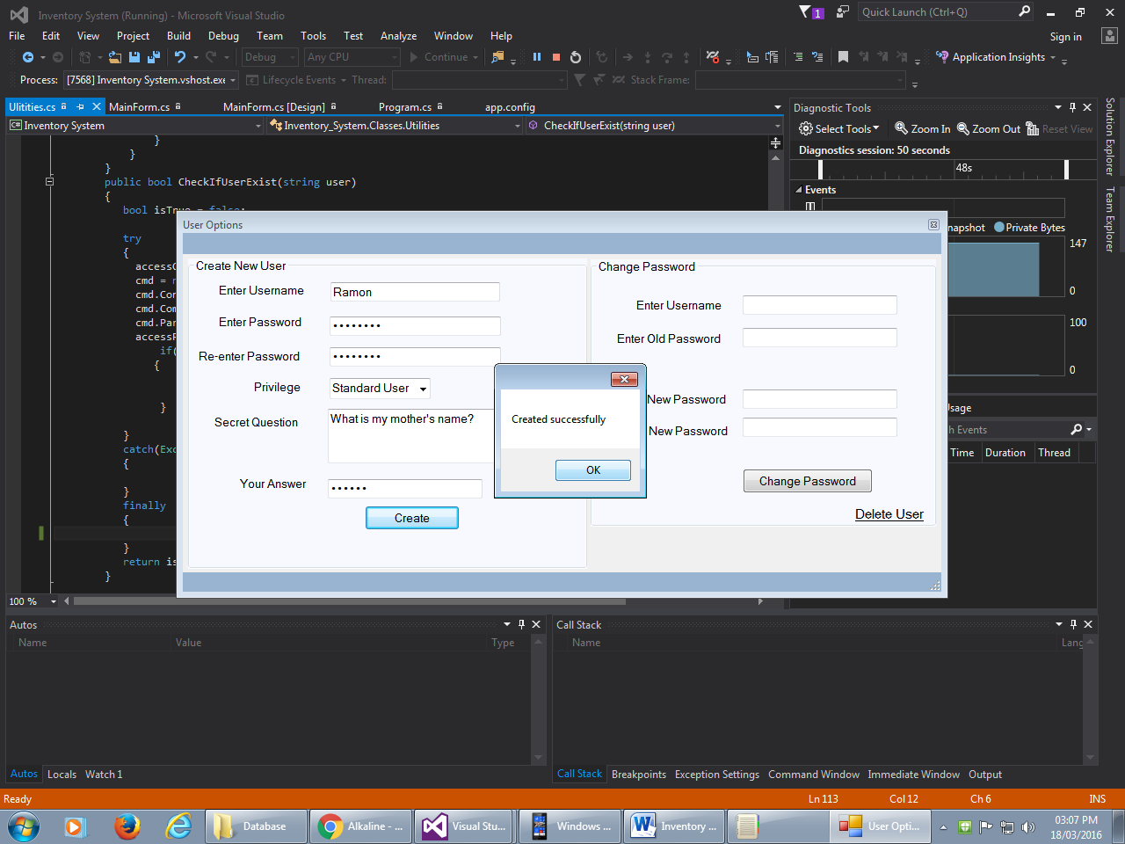

# Change User Password

Steps

1. Click icon  or select “Edit Item” from options..
2. The form below will appear. Enter the information under the section “Create Password” and click “Change Password” button. A confirmation message will appear.

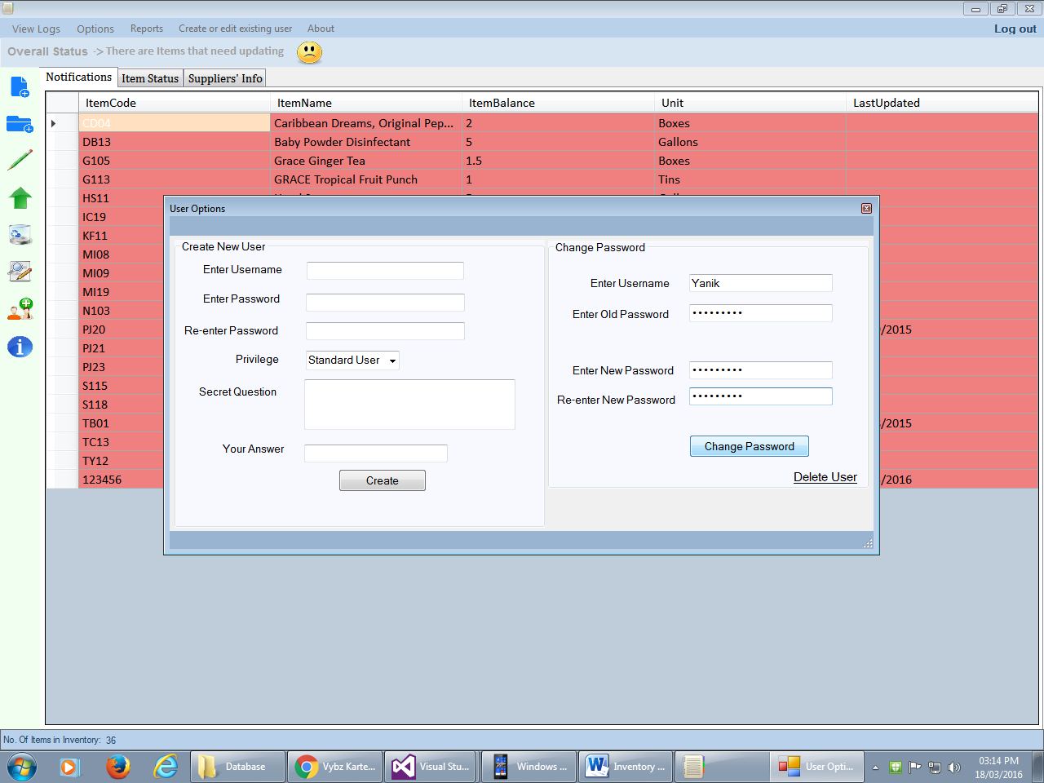

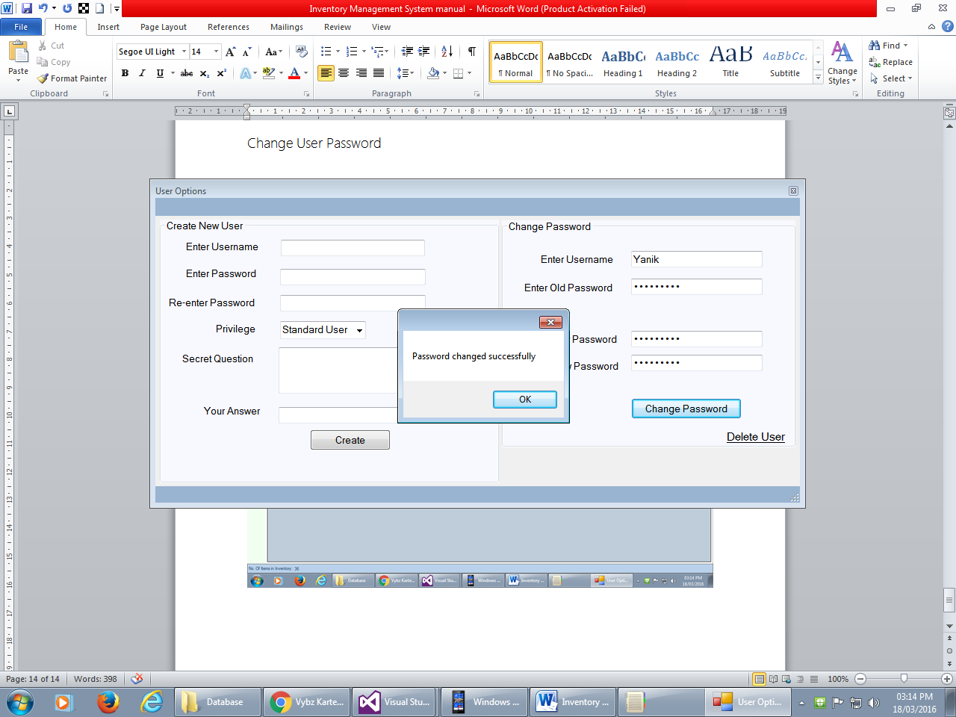

# Generate Report

Steps

1. Click Report Option 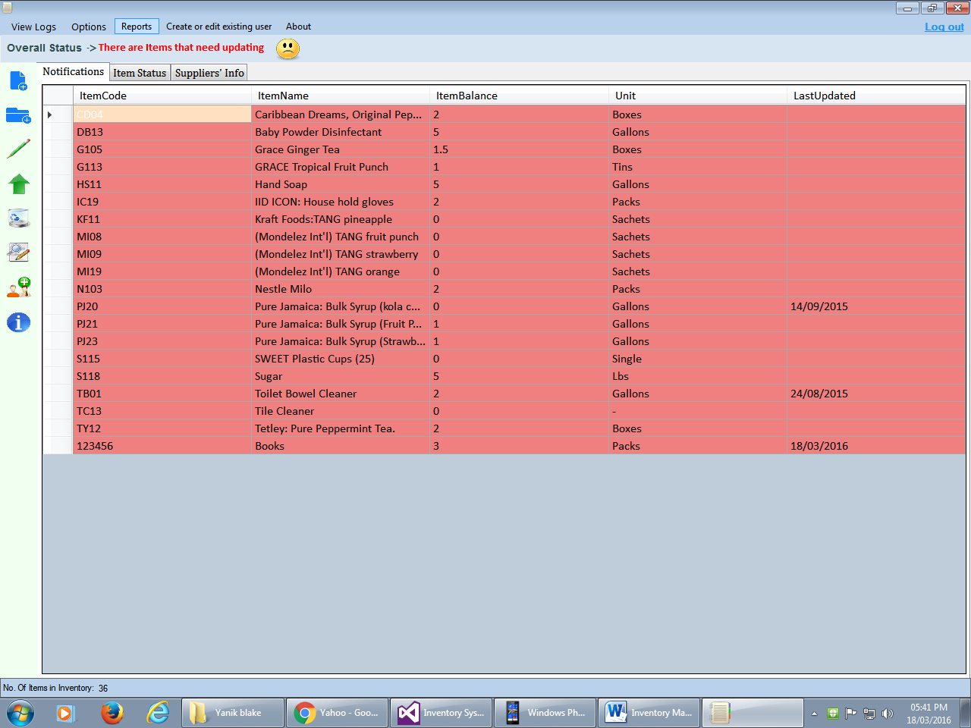
2. The form below will appear. Enter the desired information and “Generate Report” button.

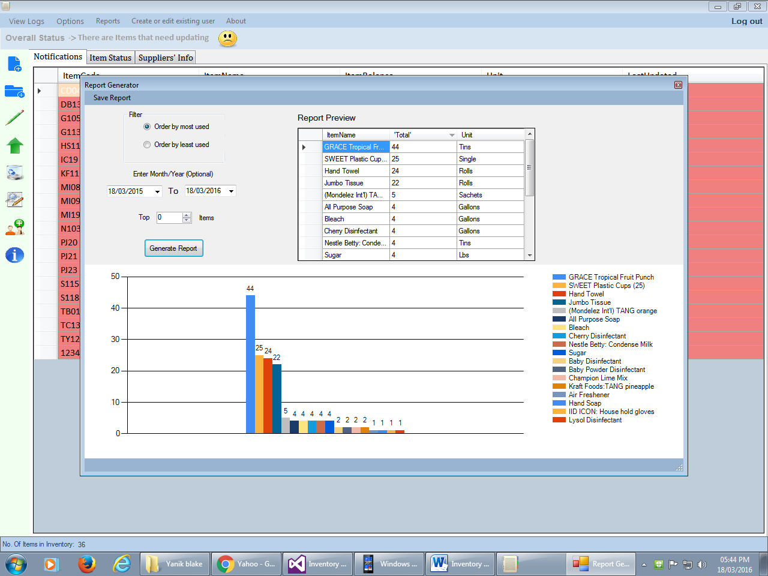

1. To save as PDF or PNG image. Click Save as Option 